Quarch Technology Ltd

AN-018 - SATA Hotswap testing

Application Note

For use with:

**QTL1490 - 6G SAS HS Drive Module**

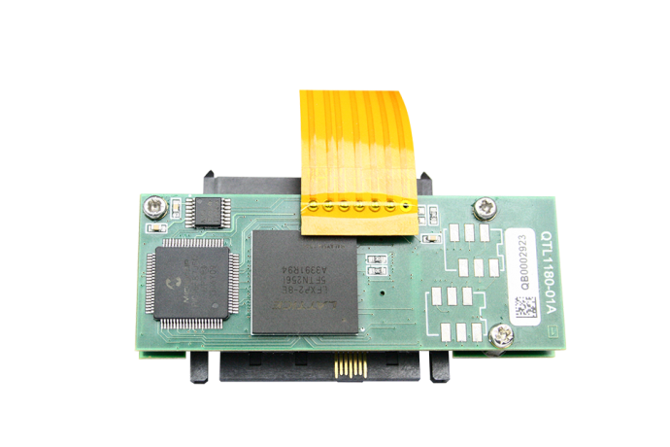

# Change History

|  |  |  |
| --- | --- | --- |
| 1.0 |  | Initial Release |

Contents

Change History 2

Requirements 4

Modules Supported 5

System Supported 5

Application Note Example Files 5

Installation and setup 6

Python install 6

QuarchPy library install 6

smartmontools install 7

Running the example 9

# Requirements

* 1. Host System
  2. SATA Drive
  3. QTL1260 – Interface Kit or Array Controller (QTL1461 or QTL1079)
  4. Quarch SAS Drive Module (e.g. QTL1490)

# Modules Supported

XLC power modules

* QTL1490 and QTL1743.

# 

# System Supported

This example is written and tested on Windows, though could be used on MacOS and Linux as long as smartmontools is installed.

It currently requires Python 2.x

# 

# Application Note Example Files

The **AN-018.zip** should be extracted to your preferred location. Please keep all file together.

|  |  |
| --- | --- |
| Script SATA Hotswap testing.py | Main python file to execute |
| lsSATA.py | Auxiliary library. |
| pySMART | Auxiliary package. |

# 

# Installation and setup

Please follow step below as necessary.

## Python install

If you do not already have Python installed, download and install it from:

<https://www.python.org/downloads/>

Under Windows it is helpful to make sure the Python installation directory and PythonXX\Scripts are included in the PATH environment variable. See:

<https://docs.python.org/2/using/windows.html#excursus-setting-environment-variables>

## QuarchPy library install

The Quarch Python package can be installed from the Python web repository (assuming you have internet access) or via the download from our website.

Quarchpy will also install a version of Quarch Power Studio

### Web Install

From the command line:

**>pip install quarchpy**

If this fails, your path to “pip” may not be set, you can instead run:

**>python –m pip install quarchpy**

### Local Install

If you want to install from a downloaded folder, ensure the folder is unzipped to a local disk, navigate to the folder containing the setup.py file and run (noting the ‘.’ on the end):

**>pip install quarchpy .**

If this fails, your path to ‘pip’ may not be set, you can instead run:

**>python –m pip install quarchpy .**

## smartmontools install

Please refer to <https://www.smartmontools.org/wiki/Download> for smartmontools installation.

You can find the latest builds for Windows in <https://builds.smartmontools.org/>

# Setup

* 1. Place the Quarch module behind the SATA drive and insert it into the host enclosure.
  2. Connect the Quarch module to the interface kit (or array controller), noting the alignment of the arrows.
  3. Connect your interface kit or array controller to your control system. This can be done via USB, serial or LAN (for array controllers only).
  4. Power on the host.
  5. Verify that the drive can be seen by the OS.
  6. Download “AN-018 - SATA Hotswap testing” and unzip the folder. Make sure you keep all files and folder from this application note together.
  7. You are ready to run *Script AN-018 - SATA Hotswap testing.py.* Note you will need to do it from an elevated command prompt.

# Running the example

* Power up the host system and verify the drive is functioning normally,
* The script will run 10 iterations of the following hot plug speeds:
  + ‘Standard’ Plug is 25ms between pin lengths
  + ‘Fast’ plug is 10ms between pin lengths
  + ‘Slow’ plug is 100ms between pin lengths
  + ‘Very Slow’ plug is 500ms between pin lengths

For each of the hot-plugs we ‘pull’ the drive, wait 10 seconds (this can be configured in *Script AN-018 - SATA Hotswap testing.py)* and verify the drive has removed without error, ‘plug’ the drive and verify that the drive returns correctly.

The timing parameters for the test specify the time between each length of pin in the connector mating (longest pins mate first).